

UNIVERSITY OF ELDORET
MAIN CAMPUS
SCHOOL OF SCIENCE
MATHEMATICS AND COMPUTER SCIENCE DEPARTMENT.
GILBERT KIPKEMOI KIPTALAM
COM/040/17

COURSE NAME: PROJECT CORE
COURSE CODE: COM 416
PROJECT TITLE: FACE RECOGNITION BASED ATTENDANCE SYSTEM

DECLARATION
I declare that this project is my original work and has not been presented in any other learning institution.

Signature……………………………….... Date ……………………………
Gilbert Kipkemoi Kiptalam
COM /040 /17
Declaration by the Supervisor
This project has been submitted for examination with my approval as project Supervisor.

Signature……………………………….... Date ……………………………

Madam Lily Siele
Supervisor

ACKNOWLEDGMENT
First and foremost, I thank Almighty God for life, health, and the ability to acquire knowledge through learning. To my dear parents for the moral, financial, physical and psychological support they accorded me, my supervisor Madam Siele for her time, dedication and the guidance she gave me while carrying out this project.
Thank you all and may our Lord God bless you.

ABSTRACT
Automatic face recognition (AFR) technologies have made many improvements in the changing world today. Smart attendance using real-time face recognition is a real world solution which comes with day to day activities of handling student attendance system. Face recognition based attendance system is a process of recognizing the students face for taking attendance by using face biometrics based on webcam and other information technology. In my face recognition project, a computer system will be able to find and recognize human faces fast and precisely in images or videos that are being captured through webcam. Numerous algorithms and techniques have been developed for improving the performance of face recognition but the concept implemented here is Deep Learning. It helps in conversion of the frames of the video into images so that the face of the student can be easily recognized for their attendance such that the attendance database can be easily reflected automatically
Keywords: Face recognition, Face detection, Deep Learning, Convolution Neural Network (CNN).

Table of Contents
DECLARATION i
ACKNOWLEDGMENT ii
ABSTRACT iii
CHAPTER 1 1
1.1. INTRODUCTION 1
1.2. BACKGROUND OF THE PROBLEM 2
1.3. PROBLEM STATEMENT 4
1.4. PURPOSE 5
1.5. OBJECTIVES 5
1.6. JUSTIFICATION 5
1.7. SIGNIFICANCE OF THE SYSTEM 6
1.8. SCOPE OF THE SYSTEM 6
1.9. LIMITATION OF THE SYSTEM 6
CHAPTER 2 7
LITERATURE REVIEW 7
2.1 Introduction 7
2.2 HISTORY 7
2.3 EXISTING SYSTEM 7
2.4 DISADVANTAGES 8
2.5 PROPOSED SYSTEM 8
CHAPTER 3 12
DESIGN AND ANALYSIS 12
3.1 Feasibility Study 12
3.2 SOFTWARE REQUIREMENT SPECIFICATION 13
3.3 USER REQUIREMENT 13
3.3.1 Functional requirements 13
3.3.2 Software requirements 13
3.3.3 Hardware requirements 13
3.4 Libraries Development 14
3.4.1 OpenCV 14
3.4.2 NumPy 16
DESIGN 16
PROPOSED SYSTEM 17
3.5 Block diagram 18
MODELLING 20
UML DIAGRAMS 20
CHAPTER 4 24
METHODOLOGY 24
4.1 Introduction 24
1. Traditional methodology 24
4.2 MODERN METHODOLOGY 27
4.3 CONCLUSION 27
Strengths of the model 28
Weaknesses of the model 28
CHAPTER 5: SYSTEM IMPLEMENTATION AND TESTING 29
5.1 IMPLEMENTATION 29
5.2 REQUIRED MODULES 30
5.3 LANGUAGES USED 30
5.3.1 PACKAGES USED IN PYTHON 31
5.4 TESTING 32
5.4.1 INTRODUCTION TO TESTING 32
5.5 TESTING STRATEGIES 33
CHAPTER 7: RESULTS AND DISCUSSION 36
REFERENCE 39
APPENDICES 41

LIST OF FIGURES
Figure 1:System Architecture for Face Recognition 16
Figure 2: Proposed system 17
Figure 3:Class Diagram for Face Recognition 19
Figure 4:Use Case Diagram for Face Recognition 20
Figure 5:Sequence Diagram for Face Recognition 21
Figure 6:Component Diagram for Face Recognition 22
Figure 7:Deployment Diagram for Face Recognition 22
Figure 8: Spiral model 24
Figure 9: Iterative waterfall model 25

CHAPTER 1

1.1. INTRODUCTION
The technology aims in imparting a tremendous knowledge oriented technical innovations these days. Deep learning is one among the interesting domain that enables the machine to train itself by providing some datasets as input and provides appropriate output during testing by applying different learning algorithms. Nowadays attendance is considered as an important factor for both the student as well as the teacher of an educational organization. With the advancement of the deep learning technology the machine automatically detects the attendance performance of the students and maintains the record of those collected data.
In general, the attendance system of the student can be maintained in two different forms namely:
- Manual Attendance System (MAS).
- Automated Attendance System (AAS).
Manual student attendance management system is a process where the teacher concerned with the particular need to call the students name and mark the attendance manually. Manual attendance may be considered as a time consuming process or sometimes it happens for the teacher to miss someone or students may answer multiple times on the absence of their friends. Sometimes in the case of giving out attendance sheet for signing to the students, you get a situation where the students sign for each other and in the end you will find out that every student signed the attendance yet all of some of them have never attended a single class.
So, the problem arises when we think about the traditional process of taking attendance in the classroom. To solve all these issues we go with Automatic Attendance System (AAS).
Automated Attendance System (AAS) is a process to automatically estimate the presence or the absence of the student in the classroom by using face recognition technology. It is also possible to ensure the presence of the student in the exam sessions. The presence of the student can be determined by capturing their faces on to a webcam. The two common Human Face Recognition techniques are:
- Feature-based approach.
- Brightness-based approach.
The Feature-based approach also known as local face recognition system, used in pointing the key features of the face like eyes, ears, nose, mouth, edges, etc., whereas the brightness-based approach also termed as the global face recognition system, used in recognizing all the parts of the image.

1.2. BACKGROUND OF THE PROBLEM
In many institutions and organizations, the attendance is a very important factor to maintain the record of students and attendance. Most of the institutions and organizations follow the manual method using old paper and file method and some of them have shifted to biometric technique. The current method that college use is that the lecturer passes a sheet or make roll calls and mark the attendance of the students and this sheet further goes to the admin department which updates the final excel sheet. This process is quite hectic and time consuming. So, why not shift to an automated attendance system which works on face recognition technique? Be it a class room or entry gates it will mark the attendance of the students. This system uses Viola and Jones algorithm for detecting and recognizing the faces. The main elements of this technology areas as follows:
- Face Detection
- Face Recognition

- Face Detection
Face detection is a computer technology being used in a variety of applications that identifies human faces in digital images. Face detection also refers to the psychological process by which humans locate and attend to faces in a visual scene. Face detection can be regarded as a specific case of object class detection. In object class detection, the task is to find the locations and sizes of all objects in an image that belong to a give class. Examples include upper torsos, pedestrians and cars. Face-detection algorithms focus on the detection of frontal human faces. It is analogous to image detection in which the image of a person is matched bit by bit. Image matches with the image stored in database.
Any facial feature changes in the database will invalidate the matching process. A reliable face-detection approach based on the genetic algorithm and the eigen-face technique:
Firstly, the possible human eye regions are detected by testing all the valley regions in the gray-level image. Then the genetic algorithm is used to generate all the possible face regions which include the eyebrows, the iris, the nostril and the mouth corners. Each possible face candidates are normalized to reduce lightning effect caused do to uneven illumination and shirring effect due to head movement. The fitness value of each candidate is measured based on its projection on the eigen-faces. After a number of iterations, all the face candidates with a high fitness value are selected for further verification. At this stage, the face symmetry is measured and the existence of the different facial features is verified for each face candidate.
- Face Recognition
A facial recognition system is a computer application capable of identifying or verifying a person from a digital image or a video frame from a video source. One of the ways to do this is by comparing selected facial features from the image and a facial database. It is typically used in security systems and can be compared to other biometrics such as fingerprint or eye iris recognition systems. Some facial recognition algorithms identify facial features by extracting landmarks, or features, from an image of the subject’s face. For example, an algorithm may analyze the relative position, size, and/or shape of the eyes, nose, cheekbones and jaw. These features are then used to search for other images with matching features. Other algorithms normalize a gallery of face images and then compress the face data, only saving the data in the image that is useful for face recognition. A probe image is then compared with the face data. One of the earliest successful systems is based on template matching techniques applied to a set of compressed face representation. Recognition algorithms can be divided into two main approaches, geometric, which looks at distinguishing features, or photometric, which is a statistical approach that distills an image into values and compares the values with the templates to eliminate variances. Popular recognition algorithms include principal component analysis using eigen faces, linear discriminate analysis, elastic bunch graph matching using the fisher face algorithm, the hidden markov model., the multilinear subspace learning using tensor representation, and the neuronal motivated dynamic link matching.

1.3. PROBLEM STATEMENT
Attendance is an important part of daily classroom evaluation. At the beginning and ending of class, it is usually checked by the teacher, but it may appear that a teacher may miss someone or some students answer multiple times. Face recognition-based attendance system is a problem of recognizing face for taking attendance by using face recognition technology based on high definition monitor video and other information technology.
The concept of face recognition is to give a computer system the ability of finding and recognizing human faces fast and precisely in images or videos. Numerous algorithms and techniques have been developed for improving the performance of face recognition. Recently Deep learning has been highly explored for computer vision applications. Human brain can automatically and instantly detect and recognize multiple faces. But when it comes to computer, it is very difficult to do all the challenging tasks on the level of human brain. The face recognition is an integral part of biometrics. In biometrics, basic traits of human are matched to the existing data. Facial features are extracted and implemented through algorithms, which are efficient and some modifications are done to improve the existing algorithm models. Computers that detect and recognize faces could be applied to a wide variety of practical applications including criminal identification, security systems, identity verification etc. The face recognition system generally involves two stages:
- Face Detection – where the input image is searched to find any face, then image processing cleans up the facial image for easier recognition.
- Face Recognition – where the detected and processed face is compared to the database of known faces to decide who that person is.

1.4. PURPOSE
- To help the lecturers improve and organize the process of tracking and managing student attendance.
- Provides a valuable attentive service for both lecturers and students.
- Reduce manual process errors by providing automated and a reliable attendance system.
- Increase privacy and security which, student cannot present him or his friend while they are not present.
- Reduce time loss as time is a very valuable resource.

1.5. OBJECTIVES
The objectives of the project are given below:
- Detection of unique face image amidst the other natural components such as walls, backgrounds etc.
- Extraction of unique characteristic features of a face useful for face recognition.
- Detection of faces amongst other face characters such as beard, spectacles etc.
- Effective recognition of unique faces in a crowd (individual recognition in crowd).
- Automated update in the database without human intervention.

1.6. JUSTIFICATION
The reason for developing this system is that:
- It will mark the attendance of the students via face Id.
- It will detect the faces via wireless camera (IP camera)/webcam and then recognize the faces.
- After recognition, it will mark the attendance of the recognized student and update the attendance record.
- The admin will be able to print these record details afterward.

1.7. SIGNIFICANCE OF THE SYSTEM
- Ease of use.
- Saves time and efforts.
- Multiple face detection.
- Multiple face recognition.
- Unknown faces are identified.
- As the system stores the faces that are detected during registration and automatically marks attendance faster. Providing authorized access.

1.8. SCOPE OF THE SYSTEM
- Provide facility for automated attendance of students.
- Use live face recognition to recognize each individual and mark their attendance automatically.
- Utilizes video and image processing to provide inputs to the system.
- Facility of marking manual attendance.

1.9. LIMITATION OF THE SYSTEM
- Difficulties with big data processing and storing without GPU and Ram below 4GB.
- Weak camera angle.
- Low-lighting and image quality.
- Deluded by identical twins.
- Requires a lot of storage space.

CHAPTER 2

LITERATURE REVIEW

2.1 Introduction
The face recognition and tracking are important in many computer vision applications. Here we develop a simple system for tracking a face in a live captured by web cam. Face recognition can be in one of two modes: Detection or tracking. In detection mode we can use a vision to detect a face in current frame. In tracking we must track the points using point tracker.

2.2 HISTORY
The subject of face recognition is as old as computer vision, both because of the practical importance of the topic and theoretical interest from cognitive scientists. Despite the fact that other methods of identification (such as fingerprints, or iris scans) can be more accurate, face recognition has always remains a major focus of research because of its non-invasive nature and because it is people's primary method of person identification.
Perhaps the most famous early example of a face recognition system is due to Kohonen, who demonstrated that a simple neural net could perform face recognition for aligned and normalized face images. The type of network he employed computed a face description by approximating the eigenvectors of the face image's autocorrelation matrix these eigenvectors are now known as eigenfaces.
Kohonen's system was not a practical success, however, because of the need for precise alignment and normalization. In following years many researchers tried face recognition schemes based on edges, inter-feature distances, and other neural net approaches. Kirby and Sirovich (1989) later introduced an algebraic manipulation which made it easy to directly calculate the eigenfaces, and showed that fewer than 100 were required to accurately code carefully aligned and normalized face images. Turk and Pentland (1991) then demonstrated that the residual error when coding using the eigenfaces could be used both to detect faces in cluttered natural imagery, and to determine the precise location and scale of faces in an image. They then demonstrated that by coupling this method for detecting and localizing faces with the eigenface recognition method, one could achieve reliable, real-time recognition of faces in a minimally constrained environment. This demonstration that simple, real-time pattern recognition techniques could be combined to create a useful system sparked an explosion of interest in the topic of face recognition. After eigenfaces fisherfaces was introduced which works more accurately than eigenfaces.

2.3 EXISTING SYSTEM
The Eigen face is the first method considered as a successful technique of face recognition. The Eigen face method uses Principal Component Analysis (PCA) to linearly project the image space to a low dimensional feature space.

2.4 DISADVANTAGES
- It is contrast based.
- Eigen face has difficulty in capturing expression changes.
- Don't provide useful information regarding the actual face.
- Cannot handle varying illumination conditions effectively.

2.5 PROPOSED SYSTEM
Fisher faces algorithm extracts useful features that discriminate one person from the others. The Fisher face is especially useful when facial images have large variations in illumination and facial expression.
2.6 ADVANTAGES
- Performs dimensionality reduction.
- More accurate than Eigen faces.
- It produces good results even under varying illumination conditions.

A counterpart Approach to attendance and Feedback System using Machine Learning Techniques:
In this paper, the idea of two technologies namely student attendance and feedback system has been implemented with a machine learning approach. This system automatically detects the student performance and maintains the student’s records like attendance and their feedback on the subjects like Science, English, etc. Therefore the attendance of the student can be made available by recognizing the face. On recognizing, the attendance details and details about marks of the student is obtained as feedback.

Automated Attendance System Using Face Recognition:
Automated Attendance System using Face Recognition proposes that the system is based on face detection and recognition algorithms, which is used to automatically detects the student face when he/she enters the class and the system is capable to mark the attendance by recognizing him/her. Viola-Jones has been used for face detection which detect human face using cascade classifier and PCA algorithm for feature selection and SVM for classification. When it is compared to traditional attendance marking this system saves the time and also helps to monitor the students.

Student Attendance System Using Iris Detection:
In this proposed system the student is requested to stand in front of the camera to detect and recognize the iris, for the system to mark attendance for the student. Some algorithms like Gray Scale Conversion, Six Segment Rectangular Filter, Skin Pixel Detection is being used to detect the Iris. It helps in preventing the proxy issues and it maintains the attendance of the student in an effective manner, but it is one of the time consuming process for a student or a staff to wait until the completion of the previous members.

Face Recognition-based Lecture Attendance System:
This paper proposes that the system takes the attendance automatically recognition obtained by continuous observation. Continuous observation helps in estimating and improving the performance of the attendance. To obtain the attendance, positions and face images of the students present in the class room are captured. Through continuous observation and recording the system estimates sitting position and location of each student for attendance marking. The work is focused on the method to obtain the different weights of each focused seat according to its location. The effectiveness of the picture is also being discussed to enable the faster recognition of the image.

In ("Face Recognition Attendance System | Employee Attendance System", 2021) proposed a system based on continuous observation and using face recognition. The author presented a system with an active student detecting method (ASD) having two cameras placed on the wall in which one is a sensing camera which is used for estimating seat inside the class and the other is capturing camera which is used for face detection. They have proposed a shooting plan in which one seat is estimated from the seating area obtained by ASD and then directs the capturing camera to the seat and captures an image. The existence of students is estimated using background subtraction and inters frame subtraction. The author has solved the linear sum assignment problem to give the correspondence of students and seats.

Paper proposed by (Jin, Zhang & Zhao, n.d.), introduced an automated system based on convolution neural networks. The author has used the GSM module to send the generated attendance report to an authorized person. The author proposes the modified convolutional neural network by adding two normalization operations to two of the layers. This operation provides the batch normalization acceleration of the network. The face recognition system is designed using the SIFT algorithm. This system will take attendance using MATLAB. The image will be captured and matched with the database and SMS is sent to the authorized number, major steps performed in this approach for generating the features are scale-space extreme detection, key point localization, orientation assignment, key point descriptor. As soon as the face is recognized by the system LED on the Arduino board will start blinking.

In ("Surveillance Camera using Face Recognition for Automatic Attendance Feeder and Energy Conservation in Classroom", 2019) two-stage hybrid face detection scheme which uses the probability-based Face Mask Pre-Filtering (PFMPF) and the pixel-based hierarchical Feature Ad boosting (PBHFA) method. This approach is aimed to solve the problem in Haar cascade. The author proposed a system with two phases, training phase, and testing phase. In the training phase, they presented two main steps first is face detection in which they have used the Viola Jones algorithm. The second step which is feature extraction after detecting faces from a video feature is extracted using the PCA algorithm. In the testing phase, the data set is partitioned into two parts named training dataset and testing dataset.

In the author (2021) used the convolutional neural network (CNN) to obtain low dimensional features as the pre-processed images are too high dimensional for a classifier to take it as input directly. For face detection, they have used the Viola and Jones algorithm and then used correlation tracker to track face from frame to frame. In this paper, the author has worked on several parameters like pose estimation, sharpness, resolution, and brightness. The head position is determined using three-angle roll, yaw, and pitch. Then approach includes final score calculation named face quality assessment by assigning weights to each of the normalized parameters.

In the author (Sutabri, Pamungkur, Kurniawan & Saragih, 2019) presented the system which used the Eigen faces approach for face recognition. They have performed face detection followed by a cropping of faces then worked on background subtraction for grayscale images and binary images. The author has used the Eigenface method due to its simplicity, speed, and learning capability.

In the author (Guo, Lin, Wu, Chang & Lee, 2021) presented the system which uses skin detection technique for face detection, after the skin is detected skin pixels are taken and the rest of the pixels in images will be made black. Then these pixels will be used for face detection authors have used two databases, the first database is for storing faces of students and the second database is for storing faces of students and the second database is for storing data of student

(Jha, Tyagi, Kumar & Sharma, 2021) introduced an automated attendance management system using face recognition technique which used the Principal Component Analysis to implement the system, uses two libraries such as OpenCV which is a computer vision library and FLTK (Light Tool Kit). Both of these libraries helped the development such as OpenCV support algorithm and FLTK used to design the interface. In the system, there are Request Matching and Adding New fact to Database. In Request Matching, the first step is open the camera and snap the photo after the extraction of the frontal face. The next step is recognizing the face with the training data and project the extracted face onto the Principal Component Analysis. The final step displays the nearest face with the acquired images. Apart from that, adding a new face into the database is snap the photo after that extract the frontal face images and then perform the Haar cascade method to find the object in the image in different window size. The next step is to store the image into the database and to learn the face then perform the Principal Component Analysis Algorithm. The final step is storing the information inside the face XML file. The system is focused on the algorithm to improve the face detection from acquired images or videos.

CHAPTER 3

DESIGN AND ANALYSIS
Analyzing the current system or the way that things are done is a must in order to come up with a system which can tackle their inefficiencies and drawbacks. This is the starting point of the system development process after the project proposal got approved. The main tasks that are coming under analyzing are; fact finding, feasibility study and come up with feasibility report and requirements specifications.
Before starting a project, the feasibility of the project should be assessed whether the project can be done with the resources available. After that, being familiar with the problem domain is the toughest task since it is a novel thing to the software developer, after the background and the flow of the work got identified it is time to do a literature review and gather facts to come up with the requirements specification.

3.1 Feasibility Study
Feasibility study is carried out when there is a complex problem or opportunity. It is considered as the primary investigation which emphasizes on “Look before You Loop” approach to any project. A Feasibility study is undertaken to determine the possibility of either improving the existing system or developing a completely new system.
- We are going to developed the new system which is feasible as our application is very user friendly and easy to understand.

3.2 SOFTWARE REQUIREMENT SPECIFICATION
The software requirements specification specifies the functional requirements and non-functional requirements.
Functional requirements refers to how the system is going to react according to the input provided and how it is going to behave in particular situations Like when the original message given is of other than English and how the system reacts when the text is of English and when the audio file is of other than „.au‟ format.
Non-functional requirements refer to Usability, Reliability, Availability, Performance, Security, Supportability, and Interface.

3.3 USER REQUIREMENT
The user requirement specifies what the user expects the software to be able to do. Once the required information is completely gathered it is documented in a URD, which is meant to spell out exactly what the software must do and becomes part of the contractual agreement. A customer cannot demand features not in the URD, whilst the developer cannot claim the product is ready if it does not meet an item of the URD. The URD can be used as a guide to planning cost, timetables, milestones, testing, etc.

3.3.1 Functional requirements
This application mainly consists of two modules:
- System
- Images/faces

3.3.2 Software requirements
The software requirements of the project are mentioned below:
- Platform : windows 10
- Environment : python 2.7/3.3

3.3.3 Hardware requirements
- System
- Camera
- Processor : Pentium IV 2.4 GHz
- Ram : 1 GB
- Hard disk : 40 GB
3.4 Libraries Development
3.4.1 OpenCV
OpenCV (Open source computer vision) is a library of programming functions mainly aimed at real-time computer vision. The OpenCV project was initially an Intel Research initiative to advance CPU-intensive applications, part of a series of projects including real-time raytracing and 3Ddisplay walls. The main contributors to the project included several optimization experts in Intel Russia, as well as Intel's Performance Library Team.

In the early days of OpenCV, the goals of the project were described as:
- Advance vision research by providing not only open but also optimized code for basic vision infrastructure. No more reinventing the wheel.
- Disseminate vision knowledge by providing a common infrastructure that developers could build on, so that code would be more readily readable and transferable.
- Advance vision-based commercial applications by making portable, performance-optimized code available for free – with a license that did not require code to be open or free itself.

OpenCV's application areas include:
- 2D and 3D feature toolkits
- Egomotion estimation
- Facial recognition system
- Gesture recognition
- Human–computer interaction (HCI)
- Mobile robotics
- Motion understanding
- Object identification
- Segmentation and recognition
- Stereopsis stereo vision: depth perception from 2 cameras
- Structure from motion (SFM)
- Motion tracking
- Augmented reality
To support some of the above areas, OpenCV includes a statistical machine learning library that contains:
- Boosting
- Decision tree learning
- Gradient boosting trees
- Expectation-maximization algorithm
- k-nearest neighbour algorithm
- Naive Bayes classifier
- Artificial neural networks
- Random forest
- SVM

Versions of OpenCV:
- Deep neural networks (DNN)The first alpha version of OpenCV was released to the public at the IEEE Conference on Computer Vision and Pattern Recognition in 2000, and five betas were released between 2001 and 2005. The first 1.0 version was released in 2006. A version 1.1 "pre-release" was released in October 2008.
- The second major release of the OpenCV was in October 2009. OpenCV 2 includes major changes to the C++ interface, aiming at easier, more type-safe patterns, new functions, and better implementations for existing ones in terms of performance (especially on multi-core systems). Official releases now occur every six months and development is now done by an independent Russian team supported by commercial corporations.
- In August 2012, support for OpenCV was taken over by a non-profit foundation OpenCV.org, which maintains a developer and user site.
- On May 2016, Intel signed an agreement to acquire Itseez, a leading developer of OpenCV.

Programming Language:
There are bindings in Python, Java and MATLAB/OCTAVE. The API for these interfaces can be found in the online documentation. Wrappers in other languages such as C#, Perl, Ch, Haskell, and Ruby have been developed to encourage adoption by a wider audience. Since version 3.4, OpenCV.js is a JavaScript binding for selected subset of OpenCV functions for the web platform.

Operating System Support:
All of the new developments and algorithms in OpenCV runs on the following desktop operating systems: Windows, Linux, macOS, FreeBSD, NetBSD, OpenBSD. OpenCV runs on the following mobile operating systems: Android, iOS, Maemo, BlackBerry 10. The user can get official releases from SourceForge or take the latest sources from GitHub. OpenCV uses CMake.

3.4.2 NumPy
NumPy is a package that defines a multi-dimensional array object and associated fast math functions that operate on it. It also provides simple routines for linear algebra and fft and sophisticated random-number generation. NumPy replaces both Numeric and Numarray.

DESIGN
Systems design is the process of defining the architecture, modules, interfaces, and data for a system to satisfy specified requirements. Systems design could be seen as the application of systems theory to product development. There is some overlap with the disciplines of systems analysis, systems architecture and systems engineering.

System Architecture
Figure 1:System Architecture for Face Recognition

PROPOSED SYSTEM
The present system of attendance marking i.e., manually calling out the roll call by the faculty have quite satisfactorily served the purpose. With the change in the educational system with the introduction of new technologies in classroom such as virtual classroom, the traditional way of taking attendance may not be viable anymore. Even with rising number of course of study offered by universities, processing of attendance manually could be time consuming. Hence, in our project we aim at creating a system to take attendance using facial recognition technology in classrooms and creating an efficient database to record them.

3.5 Block diagram
Figure 2: Proposed system

The block diagram in figure 4-1 describes the proposed system for Face Recognition based Classroom attendance system. The system requires a camera installed in the classroom at a position where it could capture all the students in the classroom and thus capture their images effectively. This image is processed to get the desired results. The working is explained in brief below: Automated Attendance System based on Facial Recognition

- Capturing Camera: Camera is installed in a classroom to capture the face of the student. The camera has to be places such that it captures the face of all the students effectively. This camera has to be interfaced to computer system for further processing either through a wired or a wireless network. In our prototype we use the in-built camera of the laptop.
- Image Processing: Facial recognition algorithm is applied on the captured image. The image is cropped and stored for processing. The module recognizes the images of the students face which have been registered manually with their names and ID codes in the database. We use haarcascade for all the image processing and acquisition operations. The whole process requires the following steps:
- Train Database: Initially we take facial image of the enrolled students. In our system we have taken three images each. This data is used later used in the facial recognition algorithm. It is done using Image Acquisition Toolbox. All the cropped image of the face is resized to a 240 X 300 image.
- Face Detection and cropping: The captured image of the classroom is initially scanned to detect faces. This is done using Computer Vision Toolbox by the function vision. CascadeObjectDetector(). This function work on the basis of Viola-Jones algorithm. This algorithm focusses more on speed and reliability. The detected faces are cropped and resized to a 240 X 300 image, same as the train database.
- Face Recognition: For recognition, the feature locations are refined and the face is normalized with eyes and month in fixed locations. Images from the face tracker are used to train a frontal Eigen space, and the leading three eigenvectors are retained. Since the face images have been warped into frontal views a single eigen space is enough. Face recognition is then performed using the Eigen face approach with additional temporal information added. The projection coefficients of all images of each person are modelled as a Gaussian distribution and the face is classified based on the probability of match.
- Attendance Recording: We use Excel spreadsheet to store the recorded attendance for easy-to-use output format, which is also the software which is familiar to majority of the institution staffs. This is done using Spreadsheet Link EX toolbox. If a student is recognized, the corresponding cell is updated with ‘1’, else a ‘0’. Using the formatting in the Excel, we can effectively retrieve the information effectively.

MODELLING

UML DIAGRAMS
Figure 3:Class Diagram for Face Recognition

Figure 4:Use Case Diagram for Face Recognition
Figure 5:Sequence Diagram for Face Recognition

Figure 6:Component Diagram for Face Recognition
Figure 7:Deployment Diagram for Face Recognition

CHAPTER 4

METHODOLOGY

4.1 Introduction

A methodology refers to the framework that is used to structure, plan, and control the process of developing an information system. It is also a system of principles from which specific methods may be derived to interpret or solve different problems in different fields. A wide variety of such frameworks have evolved over the years, each with its own recognized strengths and weaknesses. One system development methodology is not necessarily suitable for use by all projects. Each of the available methodologies is best suited to specific kinds of projects, based on various technical, organizational and project considerations. Unlike an algorithm a methodology is not a formula but a set of practices.
- Traditional methodology
Spiral model
This is a software development process for creation of new systems where failure is a big risk. Spiral projects start small, first investigating the highest risk issues then slowly expand the project once those key components are functioning. Two or more phases of prototyping are done before the final implementation. The spiral model is considered to be better than waterfall for large, expensive, complicated projects
Evaluate Alternatives
Identify, Resolve Risks
Develop, Verify
Next Level Product
Plan Next Phases
Determine Objectives,
Alternatives, Constraints
Figure 8: Spiral model

It focuses on risk assessment and on minimizing project risk by breaking a project into smaller segments and providing more ease of change during the development process, as well as providing the opportunity to evaluate risks and weigh consideration of project n throughout the life cycle. Each cycle involves a progression through the same sequence of steps, for each portion of the product and for each of its levels of elaboration, from an overall concept of operation document down to the coding of each individual program.

Its strengths are: It enhances risk avoidance and is useful in helping to select the best methodology to follow for development of a given software based on project risk. Weaknesses to spiral model are: There are no established controls for moving from one cycle to another cycle. Without controls, each cycle may generate more work for the next cycle. There are no firm deadlines. Cycles continue with no clear termination conditions there is an inherent risk of not meeting budget or schedule. It is most appropriately used in real time or safety critical systems, when risk avoidance is a high priority, when minimizing resource consumption is not an absolute priority, where requirement exists for strong approval and documentation control.

Waterfall
This is the original, traditional method of software development. It approaches software development with the view that changes after the fact are prohibitively expensive. This is a linear method in which there is a big emphasis on collecting requirements and designing the software architecture before doing development and testing. The advantage is that the project is well planned, minimizing on mid-project costs for changing requirements, and that these projects tend to be well documented.

Initial Investigation
Requirements
Definition
System Design
Coding, testing,...
Implementation
Operation &
Support
Figure 9: Iterative waterfall model

The disadvantage is that it is very hard to adjust the feature set in the middle of development, which often happens as problems are uncovered in development or changing business environments change what is needed in the software. This is such a problem that many organizations put in a place a "feature freeze" in which they refuse to alter the features to be included in a given version once software writing begins, and thus needed features get pushed to later major versions forcing the users of the software to wait years for those features.

Its strengths include: Ideal for supporting less experienced project teams and project managers, or project teams whose composition fluctuates. The orderly sequence of development steps and strict controls for ensuring the adequacy of documentation and design reviews helps ensure the quality, reliability, and maintainability of the developed software. The progress of system development is measurable and it conserves resources.

It is most appropriately applicable where a project is for development of a mainframe-based or transaction-oriented batch system. Project is large, expensive, and complicated. Project has clear objectives and solution. Pressure does not exist for immediate implementation. Project requirements can be stated unambiguously and comprehensively. Project requirements are stable or unchanging g during the system development life cycle.

MODERN METHODOLOGY

Agile Family
Agile methodology is meant to adapt to changing requirements, minimize development costs, and still give reasonable quality software. Agile projects are characterized by many incremental releases each generated in a very short period of time. Typically, all members of the team are involved in all aspects of planning, implementation, and testing. This is used by small teams, perhaps nine or fewer, who can have daily face-to-face interaction. There is a strong emphasis on testing as software is written. The disadvantages of the Agile methods are that they work poorly for projects with hundreds of developers, or where the requirements emphasize on documentation and well documented design and testing. Agile methodology advocates often find it difficult to obtain management support for implementing what seem like dramatic changes in application development. These methodologies require developers, managers and users alike to change the way they work and think. Agile methodologies include:
Extreme Programming (XP)
It is a frequent release development methodology in which developers work in pairs for continuous code review. This gives very robust, high quality software, at the expense of twice the development cost. There is a strong emphasis on test driven development.

4.3 CONCLUSION
For this project the methodology of choice is waterfall method since it is more easily applicable in the development of the project than any other methodology discussed. It is ideal for supporting less experienced project managers and teams and the progress of the system development is measurable. Waterfall method gives objectives and a solution and requirements are stable during the development life cycle therefore making the waterfall method more applicable.

Strengths of the model
- Main functionality of the system is added in the first increment
- It is generally easy to test and debug than other software development methods because relatively smaller changes are made during each iteration
- With each release, a new feature is added to the product hence customer can respond to feature and review the product
- Risk of changing requirement is reduced thus workload is reduced

Weaknesses of the model

- Each face of iteration is rigid and do not overlap each other.
- It is costly because design issues may arise: Not all requirements were gathered upfront for the entire cycle.
- As additional functionality is added to the product, problems related to the system architecture may arise which are not evident in earlier prototypes.
- Time consuming since rectifying a problem in one unit requires correction in all the units understood.

CHAPTER 5: SYSTEM IMPLEMENTATION AND TESTING

5.1 IMPLEMENTATION
Implementation is the stage in the project where the theoretical design is turned into a working system and is giving confidence on the new system for the users that it will work efficiently and effectively. It involves careful planning, investigation of the current system and its constraints on implementation, design of methods to achieve the changeover, an evaluation, of change over methods. Apart from planning major task of preparing the implementation are education and training of users. The more complex system being implemented, the more involved will be the system analysis and the design effort required just for implementation.
An implementation co-ordination committee based on policies of individual organization has been appointed. The implementation process begins with preparing a plan for the implementation of the system. According to this plan, the activities are to be carried out, discussions are made regarding the equipment and resources and the additional equipment has to be acquired to implement the new system.
Implementation is the final and important phase. This is the most critical stage in achieving a successful new system and in giving the users confidence that the new system will work is effective. The system can be implemented only after thorough testing. This method also offers the greatest security since the old system can take over if the errors are found or inability to handle certain type of transactions while using the new system.
After a classifier is trained, it can be applied to a region of interest (of the same size as used during the training) in an input image. The classifier output is “1” if the region is likely to show the face and “0” otherwise. To search for the object in the whole image one can move the search window across the image and check every location using the classifier. Here we use two different codes for face detection and tracking respectively. The algorithm used for both the codes (Processing & Arduino) is detailed in this section. Extended Haar-like Features
- Edge Features
- Line Features
- Centre-Surround Features
Before we start the actual coding, we need to install the Code Dependencies and import the Required Modules
Code Dependencies
Install the following dependencies:
- OpenCV 3.2.0
- Python v3.5
- NumPy that makes computing in Python easy. It contains a powerful implementation of N-dimensional arrays which we will use for feeding data as input to OpenCV functions.

5.2 REQUIRED MODULES
Import the following modules:
cv2: This is the OpenCV module for Python used for face detection and face recognition.
Numpy: This module converts Python lists to numpy arrays as OpenCV face recognizer needs them for the face recognition process.

5.3 LANGUAGES USED
Python
Python is an easy to learn, powerful programming language. It has efficient high-level data structures and a simple but effective approach to object-oriented programming. Python‟s elegant syntax and dynamic typing, together with its interpreted nature, make it an ideal language for scripting and rapid application development in many areas on most platforms.
The Python interpreter and the extensive standard library are freely available in source or binary form for all major platforms from the Python Website, https://www.python.org/, and may be freely distributed. The same site also contains distributions of and pointers to many free third party Python modules, programs and tools, and additional documentation.
The Python interpreter is easily extended with new functions and data types implemented in C or C++ (or other languages callable from C). Python is also suitable as an extension language for customizable applications.

This tutorial introduces the reader informally to the basic concepts and features of the Python language and system. It helps to have a Python interpreter handy for hands-on experience, but all examples are self-contained, so the tutorial can be read off-line as well.
For a description of standard objects and modules, see The Python Standard Library. The Python Language Reference gives a more formal definition of the language. To write extensions in C or C++, read Extending and Embedding the Python Interpreter and Python/C API Reference Manual. There are also several books covering Python in depth.
This tutorial does not attempt to be comprehensive and cover every single feature, or even every commonly used feature. Instead, it introduces many of Python‟s most noteworthy features, and will give you a good idea of the language‟s flavor and style. After reading it, you will be able to read and write Python modules and programs, and you will be ready to learn more about the various Python library modules described in The Python Standard Library.

5.3.1 PACKAGES USED IN PYTHON
1. OpenCV
OpenCV is the most popular library for computer vision. Originally written in C/C++, it now provides bindings for Python. OpenCV uses machine learning algorithms to search for faces within a picture. For something as complicated as a face, there isn‟t one simple test that will tell you if it found a face or not. Instead, there are thousands of small patterns/features that must be matched. The algorithms break the task of identifying the face into thousands of smaller, bite-sized tasks, each of which is easy to solve. These tasks are also called classifiers.
For something like a face, you might have 6,000 or more classifiers, all of which must match for a face to be detected (within error limits, of course). But therein lies the problem: For face detection, the algorithm starts at the top left of a picture and moves down across small blocks of data, looking at each block, constantly asking, “Is this a face? Is this a face? Is this a face?” Since there are 6,000 or more tests per block, you might have millions of calculations to do, which will grind your computer to a halt.
To get around this, OpenCV uses cascades. What‟s a cascade? The best answer can be found from the dictionary: A waterfall or series of waterfalls Like a series of waterfalls, the OpenCV cascade breaks the problem of detecting faces into multiple stages. For each block, it does a very rough and quick test. If that passes, it does a slightly more detailed test, and so on. The algorithm may have 30-50 of these stages or cascades, and it will only detect a face if all stages pass. The advantage is that the majority of the pictures will return negative during the first few stages, which means the algorithm won‟t waste time testing all 6,000 features on it. Instead of taking hours, face detection can now be done in real time. OpenCV was started at Intel in 1999 by Gary Bradsky, and the first release came out in 2000. Vadim Pisarevsky joined Gary Bradsky to manage Intel's Russian software OpenCV team. In 2005, OpenCV was used on Stanley, the vehicle that won the 2005 DARPA Grand Challenge. Later, its active development continued under the support of Willow Garage with Gary Bradsky and Vadim Pisarevsky leading the project. OpenCV now supports a multitude of algorithms related to Computer Vision and Machine Learning and is expanding day by day.
OpenCV supports a wide variety of programming languages such as C++, Python, Java, etc., and is available on different platforms including Windows, Linux, OS X, Android, and iOS. Interfaces for high-speed GPU operations based on CUDA and OpenCL are also under active development. OpenCV-Python is the Python API for OpenCV, combining the best qualities of the OpenCV C++ API and the Python language.

5.4 TESTING

5.4.1 INTRODUCTION TO TESTING
Testing is a process, which reveals errors in the program. It is the major quality measure employed during software development. During software development. During testing, the program is executed with a set of test cases and the output of the program for the test cases is evaluated to determine if the program is performing as it is expected to perform.

5.5 TESTING STRATEGIES
In order to make sure that the system does not have errors, the different levels of testing strategies that are applied at differing phases of software development are:
5.5.1 UNIT TESTING
Unit Testing is done on individual modules as they are completed and become executable. It is confined only to the designer's requirements. Each module can be tested using the following two strategies:
- Black Box Testing
In this strategy some test cases are generated as input conditions that fulsly execute all functional requirements for the program. This testing has been uses to find errors in the following categories:
- Incorrect or missing functions
- Interface errors
- Performance errors
- Initialization and termination errors.
- White Box Testing

In this the test cases are generated on the logic of each module by drawing flow graphs of that module and logical decisions are tested on all the cases. It has been uses to generate the test cases in the following cases
- Guarantee that all independent paths have been Executed.
- Execute all logical decisions on their true and false Sides.
- Execute all loops at their boundaries and within their operational bounds

5.5.2 INTEGRATION TESTING
Integration testing ensures that software and subsystems work together a whole. It tests the interface of all the modules to make sure that the modules behave properly when integrated together. Integration tessting (sometimes called integration and testing, abbreviated I&T) is the phase in software testing in which individual software modules are combined and tested as a group. It occurs after unit testing and before validation testing. Integration testing takes as its input modules that have been unit tested, groups them in larger aggregates, applies tests defined in an integration test plan to those aggregates, and delivers as its output the integrated system ready for system testing.

5.5.3 SYSTEM TESTING
It Involves in house testing of the entire system before delivery to the user. It's aim is to satisfy the user the system meets all requirements of the client's specifications. System testing of software or hardware is testing conducted on a complete, integrated system to evaluate the system's compliance with its specified requirements. System testing falls within the scope of black-box testing, and as such, should require no knowledge of the inner design of the code or logic.
As a rule, system testing takes, as its input, all of the "integrated" software components that have passed integration testing and also the software system itself integrated with any applicable hardware system(s). The purpose of integration testing is to detect any inconsistencies between the software units that are integrated together (called assemblages) or between any of the assemblages and the hardware. System testing is a more limited type of testing; it seeks to detect defects both within the "inter-assemblages" and also within the system as a whole.

5.5.4 ACCEPTANCE TESTING
It is a pre-delivery testing in which entire system is tested at client's site on real world data to find errors. Acceptance testing is a test conducted to determine if the requirements of a specification or contract are met. It may involve chemical tests, physical tests, or performance tests. In systems engineering it may involve black-box testing performed on a system (for example: a piece of software, lots of manufactured mechanical parts, or batches of chemical products) prior to its delivery.
In software testing the ISTQB defines acceptance as: formal testing with respect to user needs, requirements, and business processes conducted to determine whether a system satisfies the acceptance criteria and to enable the user, customers or other authorized entity to determine whether or not to accept the system. Acceptance testing is also known as user acceptance testing (UAT), end-user testing, operational acceptance testing (OAT) or field (acceptance) testing.
Testing can be done in two ways:
- Bottom up approach
- Top down approach

Bottom Up Approach: Testing can be performed starting from smallest and lowest level modules and proceeding one at a time. For each module in bottom up testing a short program executes the module and provides the needed data so that the module is asked to perform the way it will when embedded within the larger system. When bottom level modules are tested attention turns to those on the next level that use the lower level ones they are tested individually and then linked with the previously examined lower level modules.

Top Down Approach: This type of testing starts from upper level modules. Since the detailed activities usually performed in the lower level routines are not provided stubs are written. A stub is a module shell called by upper level module and that when reached properly will return a message to the calling module indicating that proper interaction occurred. No attempt is made to verify the correctness of the lower level module.
The important test cases will be found on appendices.

CHAPTER 7: RESULTS AND DISCUSSION
In this chapter the overall view of how face recognition attendance system works.
This chapter focuses on the output of the system.
OUTPUT
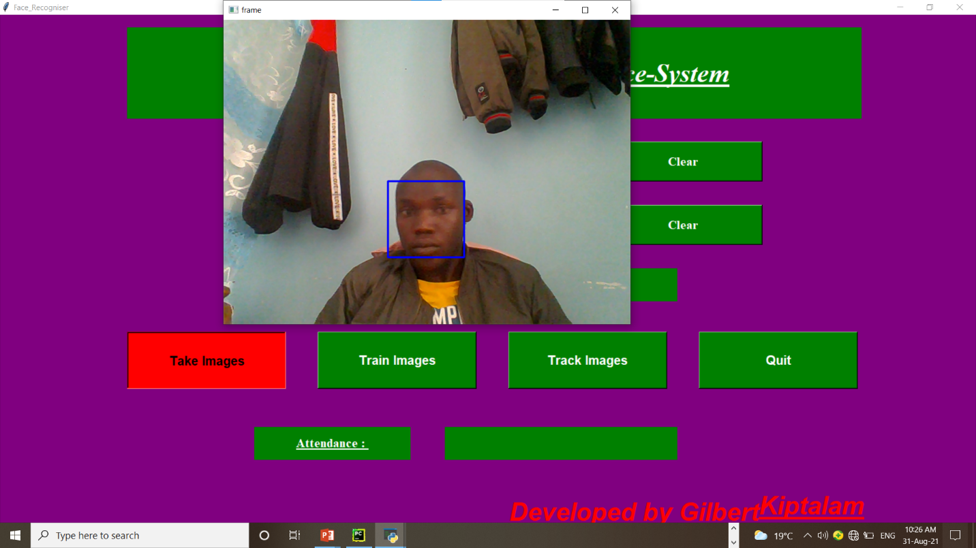
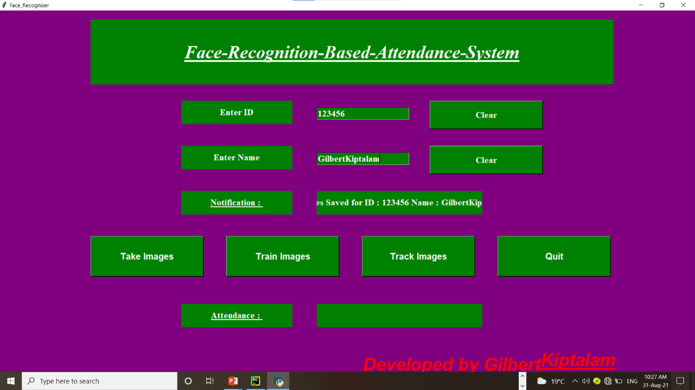
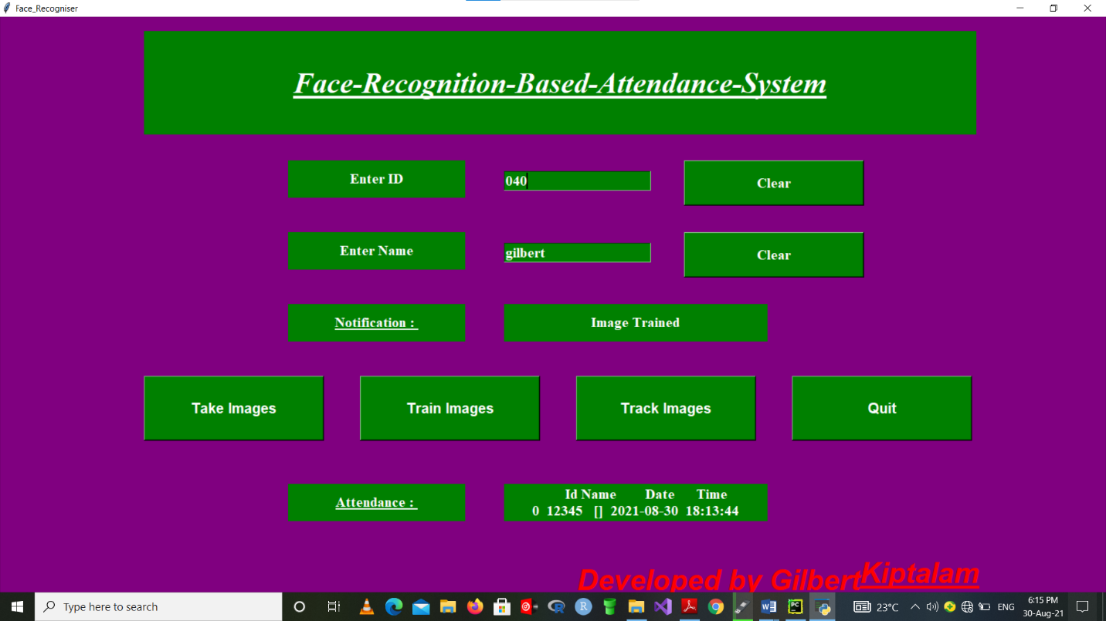
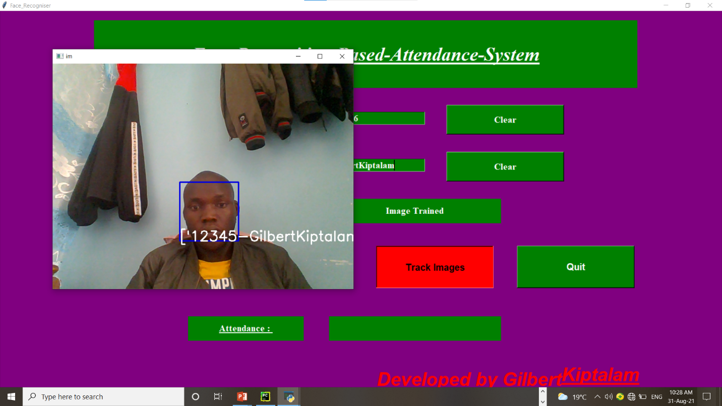
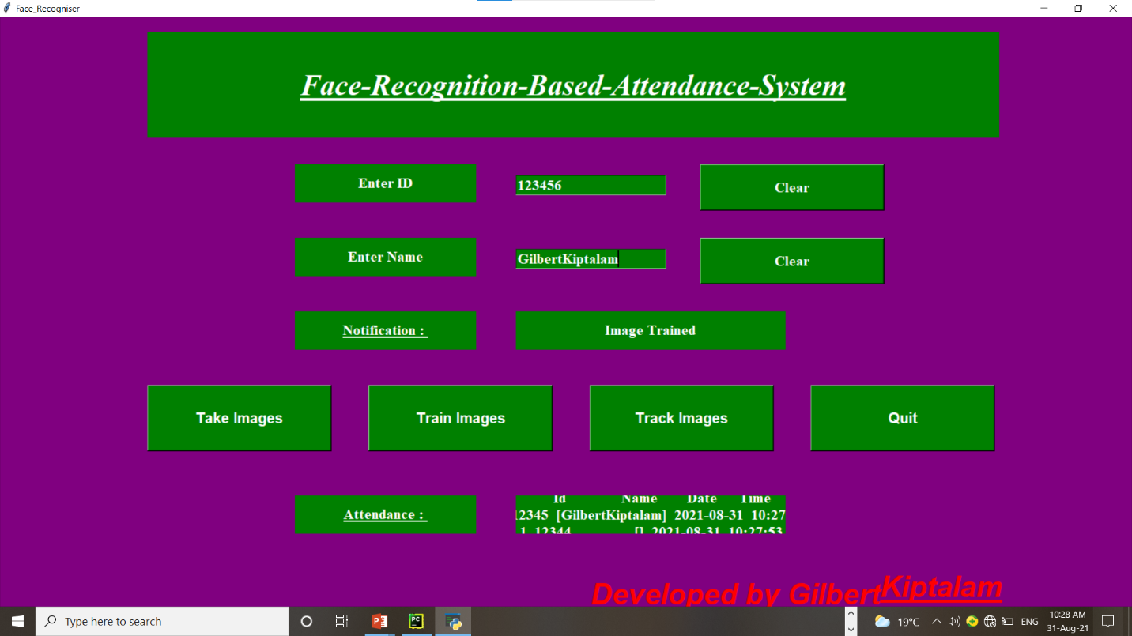


CONCLUSION

PROJECT CONCLUSION
As the fastest growing technology today, facial recognition will have many users in the near future. While facial recognition can be used to protect your privacy, it can as easily be used to invade your privacy by taking your picture when your entirely unaware of camera.

FUTURE ENHANCEMENT
The future work can be done on server-client application which could hold more number of images in both sides. If the server system fails the same image database can be recovered from the client side. Any alternative algorithm can be used in face recognition to identify the variations of face still more clearly.

REFERENCE

Jin, D., Zhang, H., & Zhao, X. Advanced research on intelligent systems and mechanical engineering.
Jha, S., Tyagi, A., Kumar, K., & Sharma, M. (2021). Attendance Management System using Face Recognition. Retrieved 24 August 2021, from https://www.ijert.org/attendance-management-system-using-face-recognition
Guo, J., Lin, C., Wu, M., Chang, C., & Lee, H. (2021). Complexity Reduced Face Detection Using Probability-Based Face Mask Prefiltering and Pixel-Based Hierarchical-Feature Adaboosting. Retrieved 24 August 2021, from
GitHub - KhomZ/Face-Recognition-Based-Student-Attendance-System-in-Python-using-OpenCV-with-Tkinter-GUI-: Face recognition-based attendance system is a process of recognizing the faces of the students while taking attendance by using face bio-metrics based on high – definition monitor video and other information technology. In this face recognition project, a computer system will be able to find and recognize human faces quickly and precisely in images or videos that are being captured through a webcam / a surveillance camera. (2021). Retrieved 24 August 2021, from https://github.com/KhomZ/Face-Recognition-Based-Student-Attendance-System-in-Python-using-OpenCV-with-Tkinter-GUI-
Face Recognition Attendance System1.1 Introduction | CustomWritings. (2021). Retrieved 24 August 2021, from https://customwritings.co/face-recognition-attendance-system1-1-introduction/
Face Recognition Attendance System | Employee Attendance System. (2021). Retrieved 24 August 2021, from https://truein.com/
(2021). Retrieved 24 August 2021, from https://www.researchgate.net/profile/Shubhobrata-Bhattacharya/publication/327006247_Smart_Attendance_Monitoring_System_SAMS_A_Face_Recognition_Based_Attendance_System_for_Classroom_Environment/links/60c0518b92851cecf165ad59/Smart-Attendance-Monitoring-System-SAMS-A-Face-Recognition-Based-Attendance-System-for-Classroom-Environment.pdf
Surveillance Camera using Face Recognition for Automatic Attendance Feeder and Energy Conservation in Classroom. (2019). International Journal Of Recent Technology And Engineering, 8(4), 3222-3225. doi: 10.35940/ijrte.d8033.118419
Sutabri, T., Pamungkur, P., Kurniawan, A., & Saragih, R. (2019). Automatic Attendance System for University Student Using Face Recognition Based on Deep Learning. International Journal Of Machine Learning And Computing, 9(5), 668-674. doi: 10.18178/ijmlc.2019.9.5.856
Weijane Lin, M. (2021). Face Recognition-based Lecture Attendance System Yohei KAWAGUCHI † Tetsuo SHOJI. Retrieved 24 August 2021, from http://citeseerx.ist.psu.edu/viewdoc/summary?doi=10.1.1.560.7003

APPENDICES
